**Lab Exercise 7 Integrating Maven with Jenkins**

**Name - Arin Agrawal**

**SapID: 500120660**

**Roll no:R2142230502**



**Step 1: Install the Maven plugin**

* 1. Open the browser, go to the Jenkins Dashboard by typing **localhost:8080** in your browser, provide the credentials, and click the **Sign in** button
  2. Click on the **Manage Jenkins** option as shown in the screenshot below:

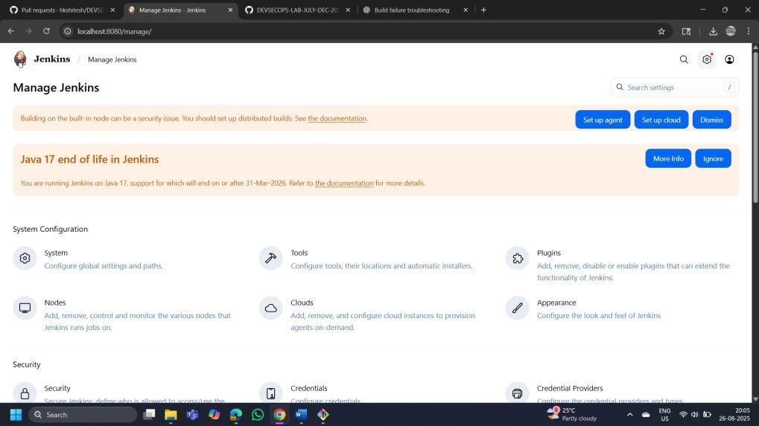



* 1. Click on the **Plugins** option as shown in the screenshot below:

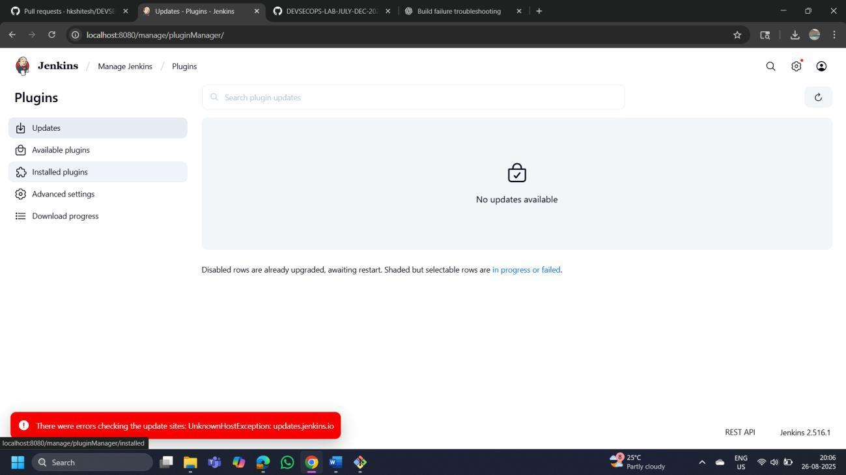

* 1. Click on **Installed plugins** to verify whether the **Maven Integration plugin** has been installed

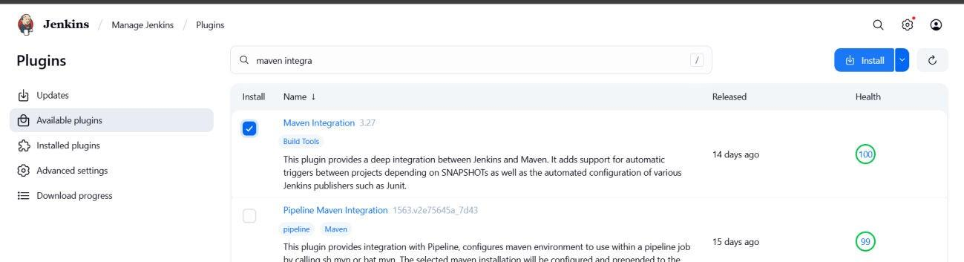

(My plugin of MAVEN was not installed so installed it)

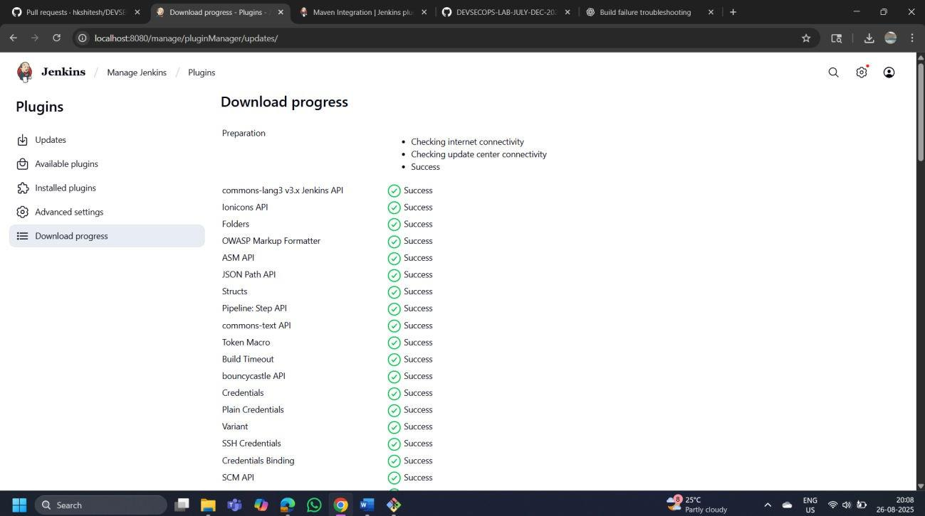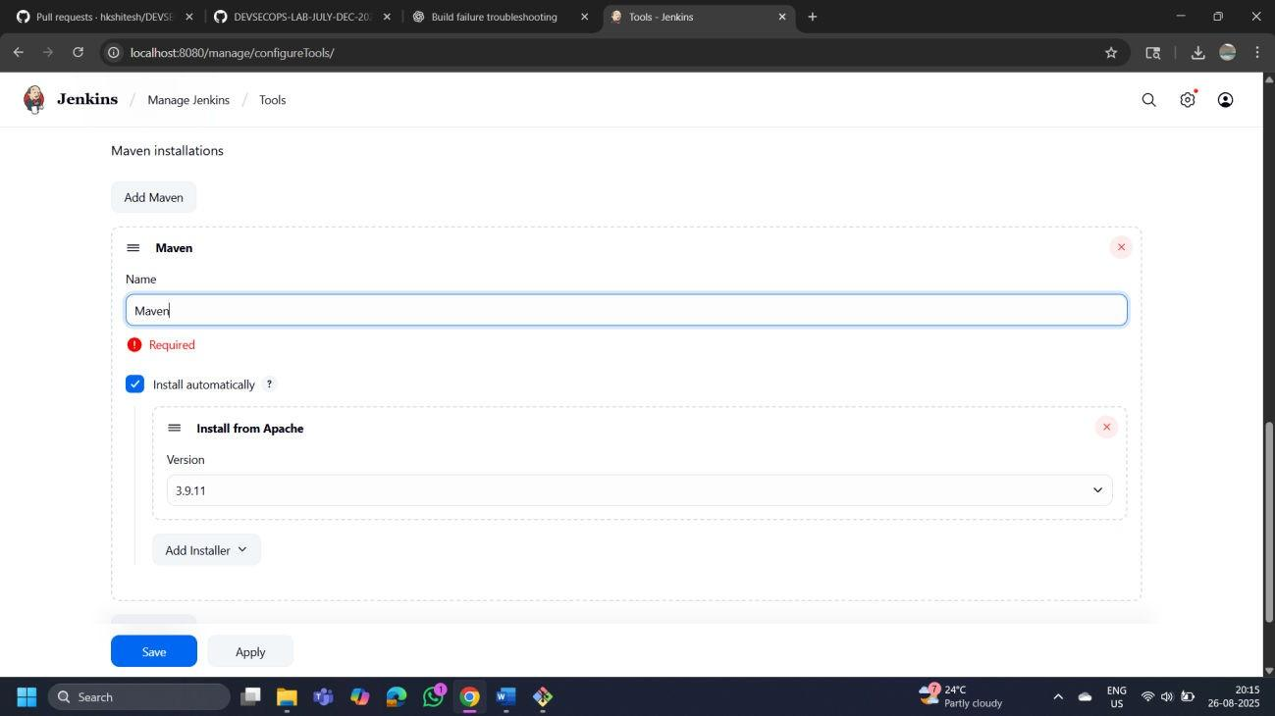

* 1. Use the following command to check the Maven version:

**mvn -version**

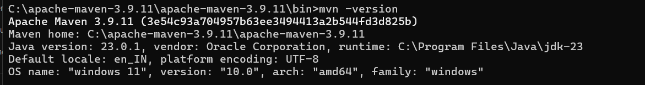

# Step 2: Set up Global Tool Configuration

* 1. Go to the Jenkins Dashboard, click on **Manage Jenkins**, and then select **Tools** from the list of options\

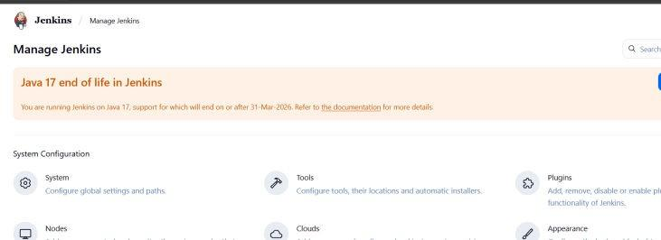

* 1. To configure Maven, click on the **Maven installations** button in the Maven section and enter a **Name** and **MAVEN_HOME** path

